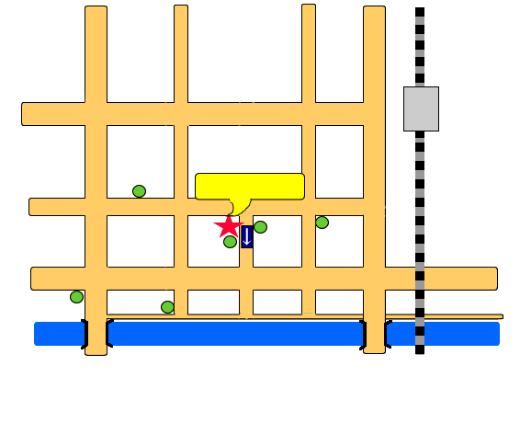
宮崎市教育情報研修センターＭＡＰ
〒 880-0803 宮崎市旭１丁目４番１号
Asahi 1- 4- 1, Miyazaki-city
PHONE:0985-28-2426 / FAX:0985-28-2436
Miyazaki
Station
Oimatsu St.
Oyodo Bridge
Tachibana Bridge
Miyazaki
City Office
Asahi St.
Miyazaki
Elementary
School
Police
Head
Quarters
Court
House
Miyazaki City Kyoiku
Joho Kenshu Center
Miyazaki
Prefecture
Office
Tachibana St.
St.
Takachiho St.
Oyodo River
Miyazaki City Kyoiku Joho Kenshu Center

